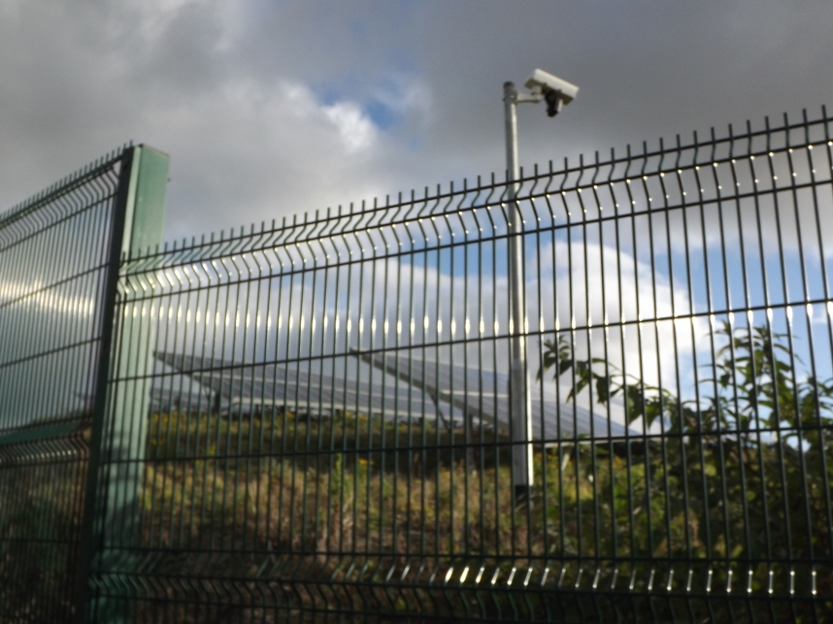

Halvasso Solar Farm:
A Greener Tomorrow?

Hundreds of people have already registered serious concerns about a proposed solar farm which would cover at least 26 acres of agricultural land in Halvasso. Many believe the site is unsuitable for industrial solar development, due to:

- Significant landscape impact. Over 11,500 raised solar panels, security fencing, small industrial buildings and more than 50 CCTV cameras. This industrialisation of the valley will seriously damage the rural character of an area currently enjoyed for its footpaths and bridleways
- Inappropriate field sizes. Multiple small fields mean unused space between field perimeters and solar panels. A more appropriate site could yield 30% more energy
- Damage to the valley’s suitability for tourism, one of Cornwall’s main sources of income
- Little or no stated benefit to the local community
- Danger of cumulative impact on the area if approval is granted. Numerous similar developments are proposed nearby, and hundreds across Cornwall
- The planning application contains numerous inaccuracies, mistakes and inconsistencies, and there has been little public consultation
- Loss of quality agricultural land
- Environmental impacts: cutting down and defoliation of over 7km of hedges supporting protected species in a county wildlife site; industrial use of pesticides beside Falmouth’s principal water supply
- Unsuitable road network due to surrounding narrow roads with low visibility
- Accoustic impact on an area which currently has some of the lowest background noise in the county: strimming throughout 3 months of the main tourist season each year; humming of inverter buildings; drilling into granite to insert c.3000 metal posts

Green energy production should not come at the expense of the local environment, when more suitable sites are available

Mabe Parish Council could be the first consultee to support local people and object to the scheme. To find out more come to the Mabe Parish Council Meeting where MPC will decide their position on:
Wednesday 21 November, 7pm in the WI Hall, Mabe.
or visit Cornwall Council’s website - http://planning.cornwall.gov.uk - to view the application - PA12/09502
Have your say!
We have an extended consultation period:
Send your comments to Cornwall Council by November 26th
Email: planning@cornwall.gov.uk with the subject ‘Comments on PA12/09502’ or via the above council website. Please request a read receipt.
Post: Comments to Planning, Circuit House, St Clement St., Truro. TR1 1EB. Stamped addressed envelopes and paper are available at Mabe shop.
Phone: Cornwall Councillor Chris Ridgers on Tel: 01872 865407 or mobile: 07791 383941

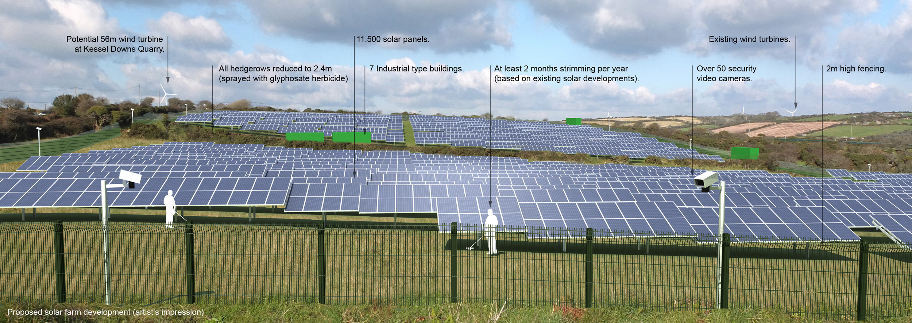

Together we can insist on sustainable and responsible green energy production

